Example:
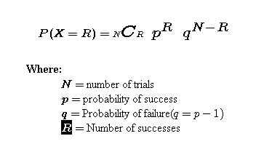
There is a 68% chance that Lebron will score on any shot. If he takes 6 shots in the first quarter find:

P(he makes exactly 4):
So N, number of attempts=6
R, number of made shots =4
N-R, number of misses = 2
p , prob he makes a shot, = .68
q, prob he misses a shot = (100-68) =.32

$$6C4*{.68}^{4}{.32}^{2}$$

6C4 = A combination = $\frac{6*5*4*3}{4*3*2*1}=\frac{360}{24}=15$
There are 15 ways he could have made 4 out of 6 shots.
So the overall odds of making exactly 4 out of 6 shots is:
$$15*{.68}^{4}{.32}^{2}=32.8\%$$

There is a Casino game (I just made up) called Roll7. It costs $3 to play. For each high number (5 or 6) you will get $1. Fill out the table.
# of high rolls | Theoretical (show work) | Experimental
0
1
2
3
4
5
6
7

